|  |  |
| --- | --- |
| AIUB | **American International University-Bangladesh (AIUB)**  **Faculty of Engineering (FE)**  **Electrical and Electronic Engineering (EEE)** |

**Course Project Presentation Guidelines and Rubrics**

**(Electronic Device Lab)**

|  |  |  |  |  |
| --- | --- | --- | --- | --- |
|  | |  |  |  |
| **Course Name:** | | Electronic Device Lab | **Course Code:** | EEE 2104 |
| **Semester:** | | Spring 2022-2023 | **Section:** | **Q** |
| **Faculty Name:** | | DR. MD HUMAYUN KABIR | | |
| **Project Title:** | | Water Level Indicator | | |
| **Project Group #** | | 05 | | |
|  | |  |  |  |
| **SL #** | **Student Name** | | **Student ID #** | **Obtained Marks** |
| **1.** | MASHFIUL KARIM TAFHIM | | 20-44070-2 |  |
| **2.** | GALIB HASAN ALVEE | | 21-44549-1 |  |
| **3.** | RAHAT MINHAZ | | 21-45768-1 |  |
| **4.** | MD. SHOHANUR RAHMAN SHOHAN | | 22-46013-1 |  |
| **5.** | SAFWAN BIN NAYEEM | | 22-47555-2 |  |

**Assessment Materials and Marks Allocation:**

|  |  |  |  |
| --- | --- | --- | --- |
| **CO** | **Assessment Materials** | **POIs** | **Marks** |
| CO3 | Communicate effectively by giving and responding to clear instructions to produce engineering solutions | **P.j.1. A2** | **20** |

|  |  |  |  |  |  |  |
| --- | --- | --- | --- | --- | --- | --- |
| **CO** | **Excellent**  **[16 to 20]** | **Best**  **[11 to 15]** | **Better**  **[6 to 10]** | **Good**  **[1 to 5]** | **No Response**  **[0]** | **Secured Marks** |
| **CO3**  **P.j.1. A2** | Students could explain the whole project with all functionalities, application, limitation, future scopes and so on | Students could explain the whole project with limited knowledge of functionalities but capable of mentioning the application, limitation, future scopes and so on | Students could demonstrate the project without having knowledge of functionalities of the components but capable of mentioning some of the features | Students have little knowledge of the electronic device components, project objective | No Response |  |
| **Comments:** | | | | | **Total Marks (20)** |  |

Project criteria: Any practical electronic circuit which includes at least one BJT and/or MOSFET.

**The presentation should include following points (not limited to these)**

1. **Introduction**
2. **Motivation**
3. **Novelty/Difference with existing similar projects**
4. **Methodology**
5. **Result and discussion**
6. **Project cost**
7. **Limitation**
8. **Conclusion**
9. **References**

**Table of Content:**

|  |
| --- |
| 1. **Introduction** |
| 1. **Motivation** |
| 1. **Novelty/Difference with existing similar project** |
| 1. **Methodology** |
| 1. **Result and Discussion** |
| 1. **Project Cost** |
| 1. **Limitation** |
| 1. **Conclusion** |
| 1. **References** |

**Introduction:**

The water level indicator is an essential device for monitoring the water level in various water reservoirs. It helps to prevent overflow, save water, and protect the water pump from dry running. In this presentation, we present a water level indicator electronics project that uses a simple circuit to indicate the water level in a tank.

**Motivation:**

The need for a water level indicator arises from the fact that water is a precious resource, and wastage of water due to overflowing or dry running of the pump is not only harmful to the environment but also causes a financial loss. Therefore, a water level indicator is a cost-effective and practical solution to this problem.

**Novelty/Difference with existing similar projects:**

The novelty of this project lies in its simplicity and ease of construction. Most existing similar projects require complex circuits, microcontrollers, or expensive components, making them difficult to build for beginners. In contrast, this project uses only a few inexpensive and easily available components, making it an ideal choice for novice hobbyists.

**Methodology:**

The water level indicator circuit consists of a transistor, LEDs, a 4.7 kΩ resistor, two 100 Ω resistors, a buzzer, a 9V battery, a breadboard and connecting wires.

The positive terminal of the battery is connected to the breadboard’s positive rail & negative terminal is connected to the negative rail. The emitter of the transistor is connected to the negative rail & a 4.7 k Ω resistor is connected across the transistor’s base & negative point of the battery. Another 100 Ω resistor is connected across the base & water tank by wire. Another 100 Ω resistor is connected across battery’s positive terminal and another point is connected to the LED’s positive terminal where the negative point of the LED is connected to collector. Similarly, Buzzer is also parallelly connected across the LED. The secondary connecting wire of the water tank is connected to this 100 Ω resistor. When the water level rises and reaches the probe's level, the transistor gets triggered, and the LED lights up and the buzzer sounds, indicating that the water level has risen to a certain level.

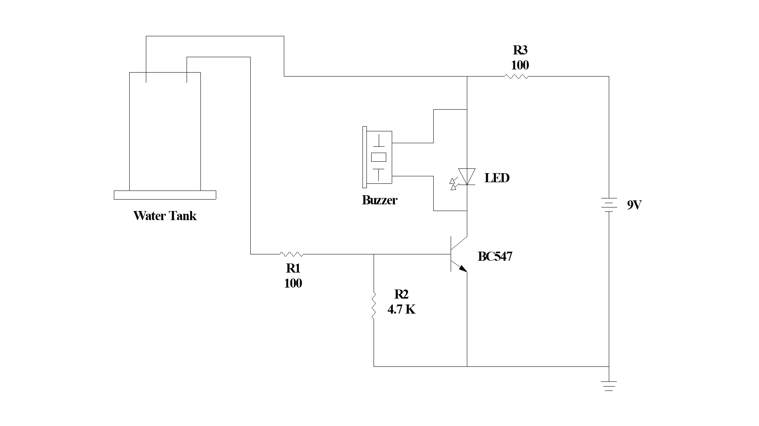

Figure 1: Circuit diagram

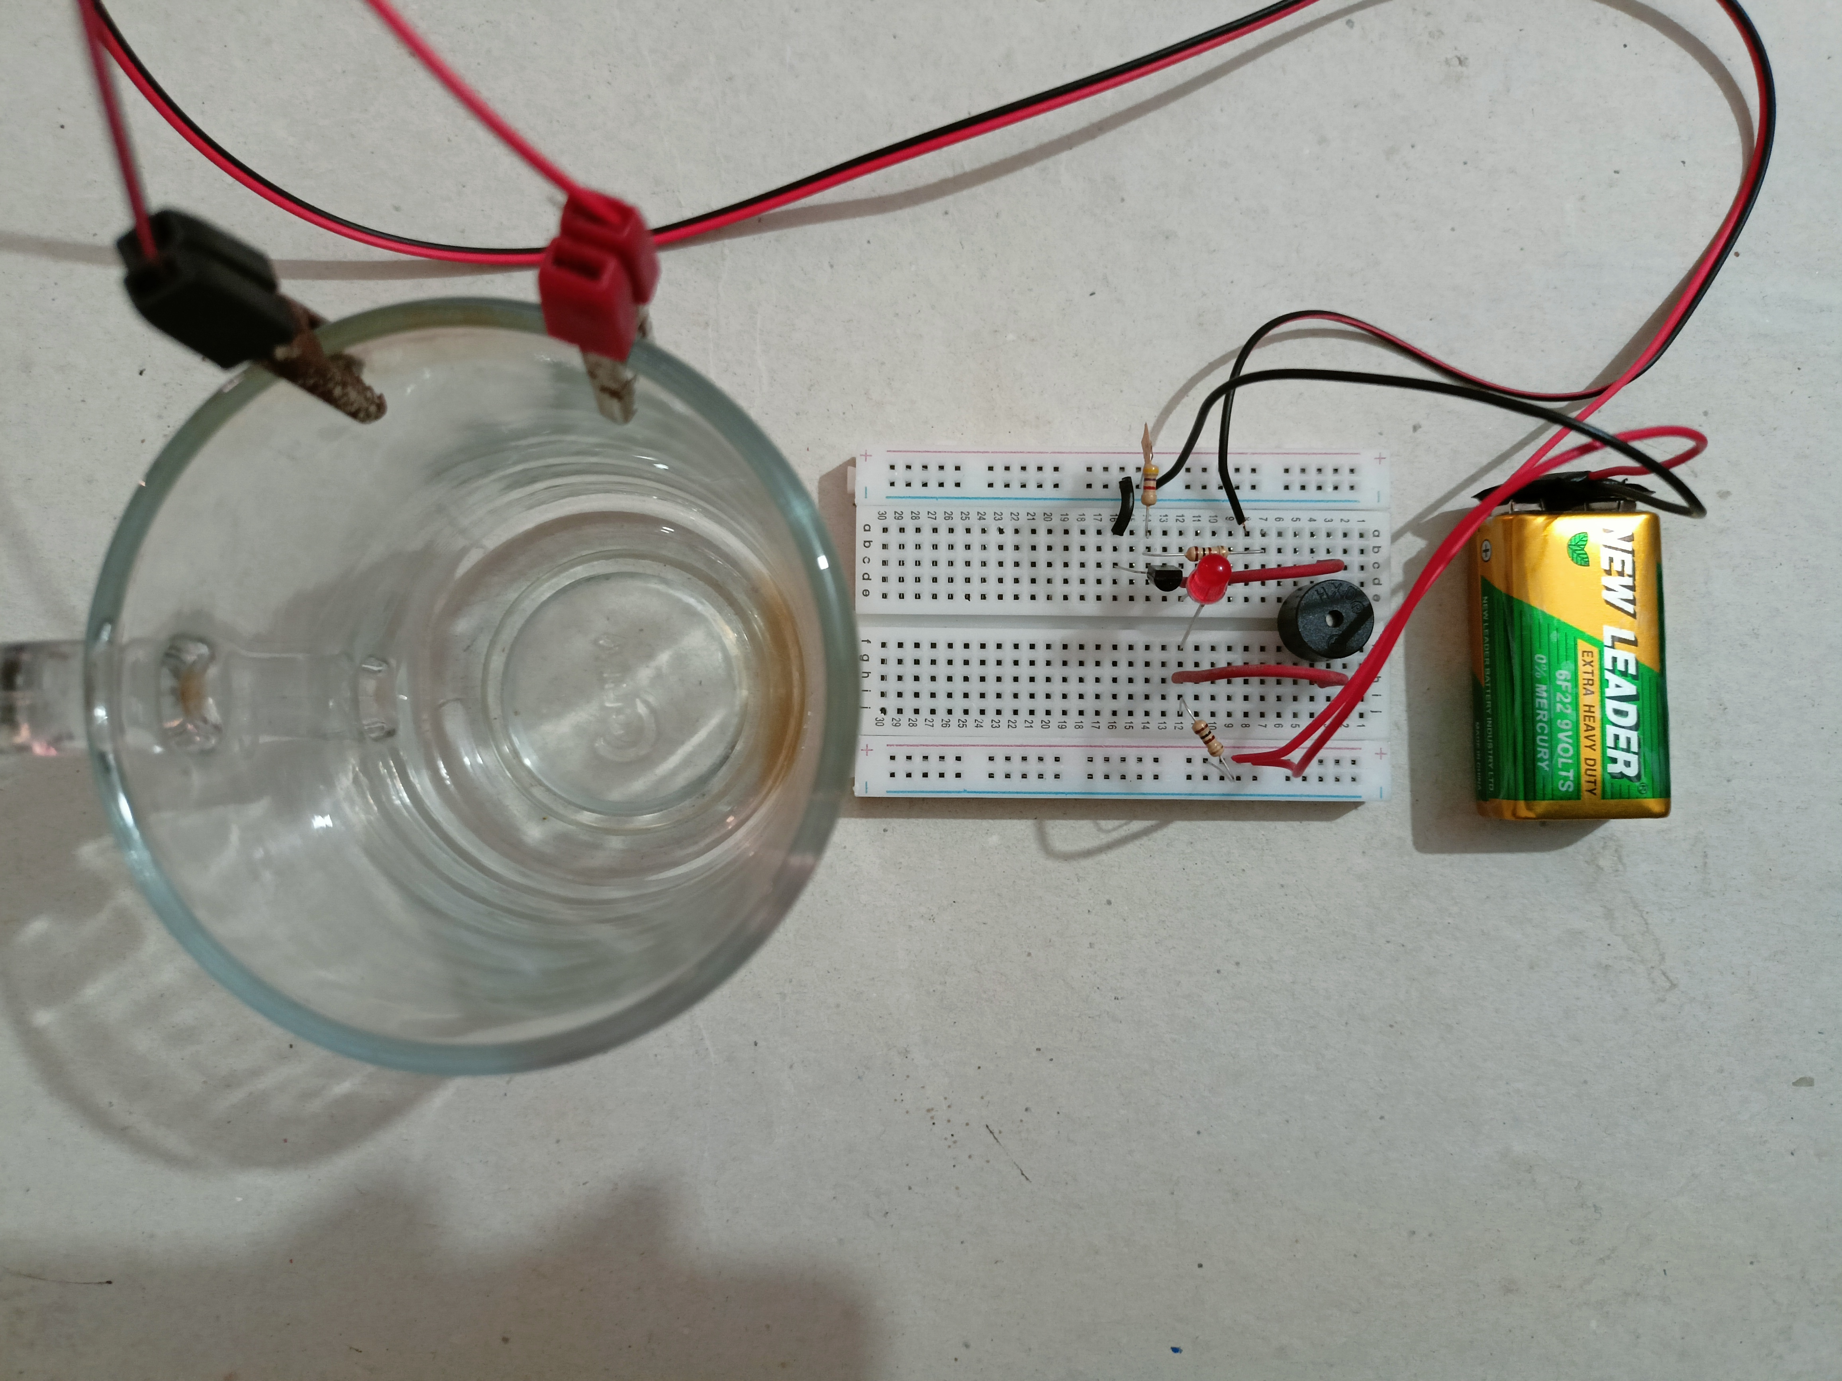

Figure 2: Physical implementation of circuit (when water tank is empty)

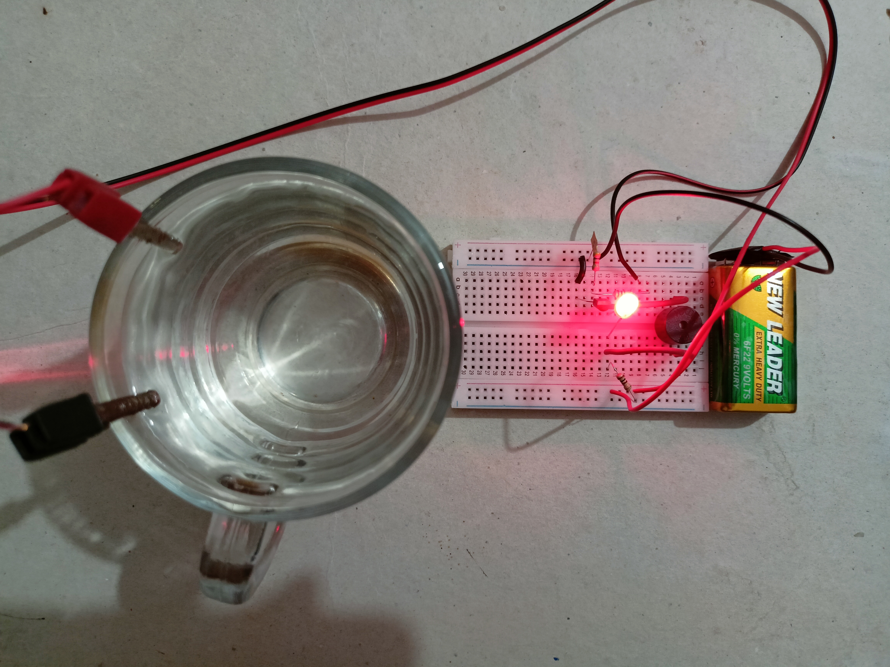

Figure 3: Physical implementation of circuit (when water reach to the probes)

**Result and Discussion:**

The water level indicator circuit was successfully implemented using necessary component which we discuss in methodology part. The circuit was tested with a demo water tank, and the results were satisfactory. The LED indicators lit up and buzzer turn on according to the water level in the tank, indicating a full level.

**Project Cost:**

|  |  |  |  |
| --- | --- | --- | --- |
| **#** | **Items** | **Quantity** | **Amount** |
| **1** | Small Breadboard | 1 | 84.8 |
| **2** | 9V Battery | 1 | 84 |
| **3** | 9V Battery Connector | 1 | 11.9 |
| **4** | 100 **Ω** ¼ W Resistor | 2 | 3.98 |
| **5** | 4.7 K**Ω** ¼ W Resistor | 1 | 1.85 |
| **6** | Red LED (5mm) | 2 | 3.9 |
| **7** | NPN Bi-polar Junction Transistor (BC547) | 1 | 2.7 |
| **8** | Buzzer (3-9V) HQ | 1 | 21.8 |
| **9** | Electrical Wire (1 Feet) | 2 | 9.86 |
| **10** | Crocodile Clip (Pair) | 1 | 10 |
| **11** | Miscellaneous | - | 60 |
| **12** | **Grand Total** | - | **294.79 BDT** |

**Limitation:**

The water level indicator circuit presented in this project has some limitations. It is not suitable for very large water tanks or reservoirs due to the limited number of LED indicators. Additionally, the circuit is not waterproof, and care must be taken to prevent it from getting wet.

**Conclusion:**

In conclusion, the water level indicator electronics project presented in this project is a simple and effective solution for monitoring the water level in a tank. It is easy to construct, cost-effective, and can be built by novice hobbyists with basic electronics knowledge. This project can help save water, prevent overflow, and protect the water pump from dry running.

**References:**

[1] Liyan Gong, "BC547 Transistor Basic Knowledge, Pinout and Application", <https://www.seeedstudio.com/blog/2020/09/10/bc547-transistor-basic-knowledge-pinout-and-application/>

[2] Water level (device), <https://en.wikipedia.org/wiki/Water_level_(device)>

[3] Robodoc, <https://robodocbd.com/>